Dear User,

We hope this email finds you well.

We are writing to inform you about a recent change in the login functionality for the IMSpeedo External application. We have implemented a new Single Sign-On (SSO) feature that will improve the security and user experience for the application.

With this new feature, you will no longer need to use the old login credentials to access the application. Instead, you will be required to use your SSO login credentials, which have been created for you and shared to you on **19-Jul-23**, in your registered email-ID. Please ensure that you use the same username and password shared with you in the email.

The login process is now as follows:

1. Visit the following URL: <https://apac.ingrammicro.com/imspeedo>
2. Click on the highlighted link labeled "Login" to access the SSO login page.

Enter your SSO login credentials, including the username and password shared with you via email.

Create a new password as prompted and click "Sign In".

You will then be taken to Home/Landing Page

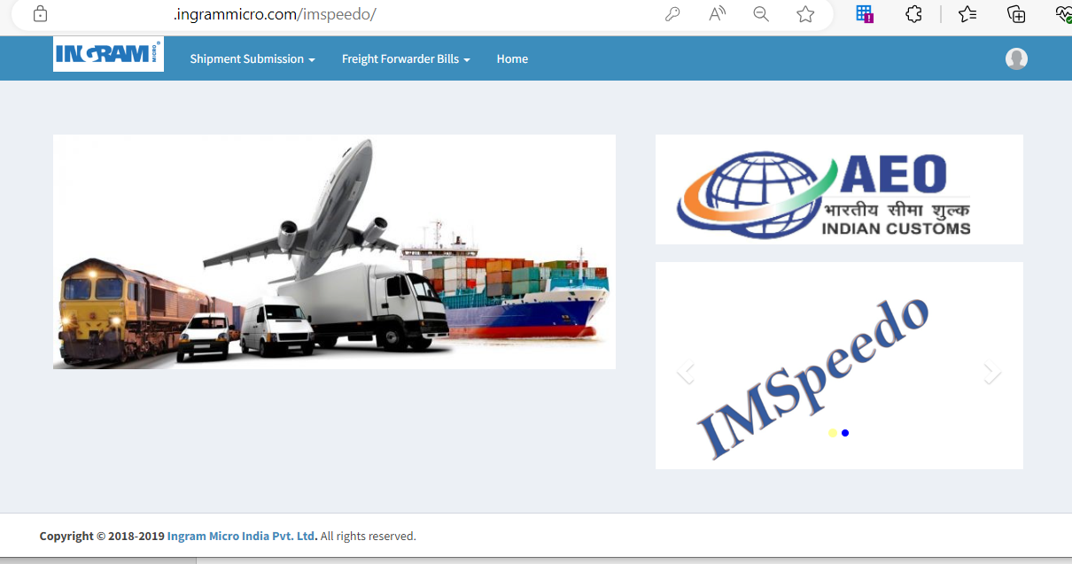

We have made this change to enhance the security of the application, and we believe that it will provide a better user experience for you.

If you encounter any issues with the new login process, please do not hesitate to contact us and the contact details has been shared on the website.

Thank you for your cooperation and understanding.

Best regards,

Technical Team.

Ingram Micro Inc.